**Business Case: Swiggy – Funnel Analysis**

**Introduction:**

**Swiggy** is an Indian online food ordering and delivery platform. Founded in 2014, Swiggy is headquartered in Bangalore and operates in more than 500 Indian cities as of September 2021. Besides food delivery, the platform also provides on-demand grocery deliveries under the name Instamart, and same-day package delivery service called Swiggy Genie.

**Purpose:**

The Purpose of this case study is to analyse the performance of Swiggy for the year 2019. Swiggy has over 1 million users transacting on the platform on a daily basis. Through this case study we aim to analyse-

1. User behaviour throughout the sales funnel (L2M, M2C, C2P & P2O)
2. Identify fluctuations in the conversion rates and bottlenecks resulting in the drop-off at any stage
3. Evaluating the effectiveness of marketing campaigns via different channels

**Data and Analysis:**

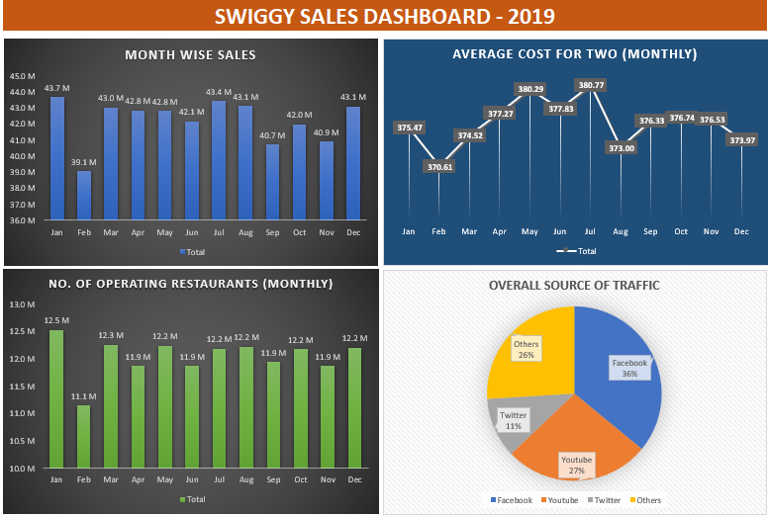

**Insights from Dashboard:**

* Highest monthly sales observed in the month of Jan 2019 where the number of operating restaurants was also the highest, followed by July, Aug, Dec etc.
* Lowest monthly sales observed in Feb 2019 where the number of operating restaurants was also the lowest
* The Primary source of traffic is Facebook, followed by YouTube, Twitter and Others

**Date wise Analysis for Fluctuations over (+/-20%) w.r.t. same day in the previous week:**

|  |  |  |
| --- | --- | --- |
| **Date** | **Order Change w.r.t same day last week** | **Reason** |
| 10-01-2019 | -45% | Reduction in orders due to reduction in Traffic by -49% (Facebook (FB) -95%, YouTube (YT) and Twitter (TW) -49%) |
| 17-01-2019 | 106% | Increase in orders due to increase in Traffic by +110% (FB +1980%, YT and TW +110%) |
| 21-01-2019 | 23% | Increase in orders (1.48M) due to M2C increase at (42%) , Images per restaurant Increased from (31) to (37) |
| **22-01-2019** | **85%** | **Highest orders (2.22M) due to Increase in Traffic by +77% (FB +77%, YT -66%, TW +747%, Others -66%)** |
| 29-01-2019 | -72% | Reduction of Traffic by -40% (FB -40%, Others -80%) Count of Restaurants lowest at 0.27M resulting in decline in order conversion at (3%) |
| 05-02-2019 | 115% | Increase in conversion +115%, Traffic constant but Count of Restaurants at (0.4M) |
| 19-02-2019 | -56% | Reduction in conversion rate by -54% due to reduction in M2C from conversion (39%) to (17%) |
| 26-02-2019 | 120% | Increase in conversion rate by +110% due to increase in M2C conversion from (17%) to (41%) |
| 28-02-2019 | 22% | Increase in conversion rate by +13% due to slight increase in traffic by 8%, Average out of stock items reduced from (36) to (30) |
| **02-03-2019** | **-38%** | **Lowest Overall conversion at (2%), Highest Average Delivery Charges at (56) resulting in Lowest C2P at (33%)** |
| 09-03-2019 | 102% | Increase in conversion rate by +102% due to Reduction in Average Delivery Charges to Half at (28) |
| **19-03-2019** | **-46%** | **Reduction in orders (0.7M) Lowest P2O at (39%) and Lowest Success Rate of payments at (65%) which could mean an issue with the Payment options on the app** |
| 24-03-2019 | 22% | Increase in conversion rate due to slight increase in traffic (+6%) due to it being a Weekend |
| 26-03-2019 | 78% | Increase in conversion rate by +87% as the Success Rate of payments is at (94%) as compared to the lowest of (65%) from previous week |
| **04-04-2019** | **-52%** | **Reduction in orders (0.6M) and conversion rate -53% due to Lowest Average discount at (10%)** |
| 11-04-2019 | 92% | Increase in conversion rate due to increase in discount % at (18%) and slight reduction in average packaging (19) and delivery charges (25) |
| 12-04-2019 | -27% | Reduction in conversion rate by -20% due to slight change in Traffic (-9%) |
| 14-04-2019 | 28% | Increase in conversion rate by 19% due to slight change in Traffic (8%) due to it being a Weekend |
| **18-04-2019** | **73%** | **Increase in conversion rate due to Highest Overall conversion (9%) and Highest average discount (29%)** |
| 19-04-2019 | 25% | Increase in conversion rate by +16%, Highest C2P at (77%) |
| 25-04-2019 | -39% | Reduction in conversion rate by -39% due to reduction in average discount from (29%) to (17%) |
| 20-06-2019 | -54% | Reduction in orders (0.6M) and conversion rate due to reduction in Traffic by -53% for all channels |
| 27-06-2019 | 115% | Increase in orders (1.3M) due to increase in Traffic by +119% for all Channels, correction from previous weeks low of -54% |
| **16-07-2019** | **-63%** | **Lowest Overall Conversion (2%) and Lowest L2M (10%) due to Highest Average Cost for two (458)** |
| 23-07-2019 | 135% | Increase in conversion rate from previous week by 128% due to L2M increase to 24% resulting from reduced average cost for two, packaging and delivery charges |
| **11-08-2019** | **-54%** | **Lowest Overall conversion at (2%), Highest Average Packaging Charges at (29) resulting in Lowest C2P at (33%)** |
| 18-08-2019 | 107% | Increase in conversion rate by +100% due to Average packaging charges reduced to (20) resulting in C2P increase to (65%) |
| **14-09-2019** | **-54%** | **Lowest Overall conversion at (2%) with M2C reduced to (15%) due to increase in Average out of stock items to (64)** |
| 21-09-2019 | 112% | Increase in conversion to +114% with M2C increased to (34%) and out of stock items reduced to (37) from (64) in previous week |
| 09-10-2019 | 22% | Increase in overall conversion to +27% from -19% in the previous week, Highest C2P at (77%) |
| 21-10-2019 | 32% | Increase in overall conversion to +21% from -17% in the previous week |
| 09-11-2019 | 26% | Increase in conversion rate by 18% due to slight change in Traffic (7%) due to it being a Weekend thereby increasing the M2C and P2O conversions |
| **17-11-2019** | **-57%** | **Lowest Overall conversion at (2%) with M2C reduced to (14%) due to Highest Average out of stock items (112)** |
| 24-11-2019 | 135% | Increase in conversion rate from previous week by 124% due to L2M increase to 34% resulting reduced average out of stock items to (34) |
| 01-12-2019 | 21% | Increase in conversion rate from previous week by 20% |
| 22-12-2019 | 21% | Increase in conversion rate from previous week by 21% |

*\*Highlighted cells are for the lowest and highest conversion rates*

**Recommendations:**

Below are few recommendations based on the analysis for the data provided above. These recommendations are to help strengthen relations of Swiggy with all stakeholders involved and thereby improve overall sales and profits.

* ***Strengthen Relationships with Partner Restaurants and provide incentives for Long-term commitment:*** Develop strong, long-term relationships with partner restaurants through regular communication and collaboration. Also, offer incentives or loyalty programs for restaurants that commit to being consistently available on the platform. This could include reduced commission rates, marketing support, or exclusive promotions.
* ***Performance recognition programs for Delivery Partners:*** Consider implementing incentive programs for high performance of delivery partners, such as bonuses, rewards, or recognition. A motivated and fairly compensated workforce is more likely to provide better service.
* ***Run Targeted Promotions:*** Lowest user traffic is coming from Twitter. Run channel-specific promotions or discounts. Highlight exclusive offers available only to users who engage with Swiggy through Twitter or other channels where traffic is less, encouraging them to visit the app or make a purchase.
* ***Segmented Pricing Tiers:*** Highest conversion rate for the year was at 9% on the day Swiggy offered the highest discounts. Segmented pricing can be done on the basis of customer preferences and spending behaviours. This can help to cater different market segments and improve conversion rates
* ***Offer Incentives for Pre-Orders:*** Provide exclusive discounts or promotions for users who opt for pre-orders, incentivizing them to plan their meals in advance. This will also help restaurants in pre-planning the demand of popular items which may go out of stock often
* ***Customer Feedback Analysis:*** Understanding the concerns of customers is crucial for targeted improvements. Collecting and analysing customer feedback to identify pain points in the conversion process can help to optimize the user experience and improve conversion.
* ***Continuous Monitoring and Adjustment:*** Continuously monitoring conversion rates and associated metrics would help to adjust strategies based on real-time data, user feedback, and market trends.